**Q.1- a**

1. Create table named department with following columns

(Dep_id int,

dep_name varchar,

dep_location varchar )

a. Add primary key to Dep_id column

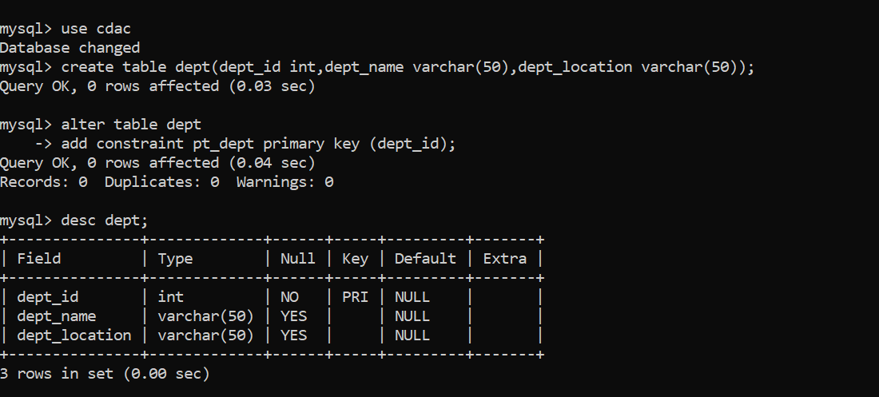

**Q.1 B**

Add Default constraint to dep_location with default value

‘Mumbai’

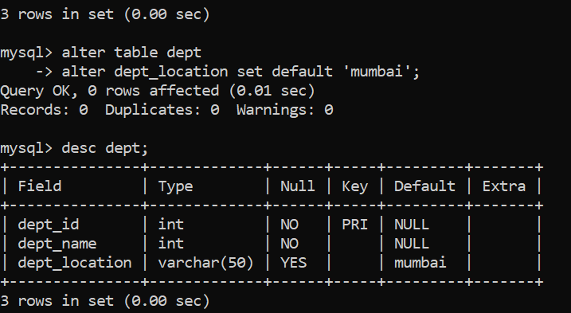

C. Add NOT NULL constraint to dep_name column

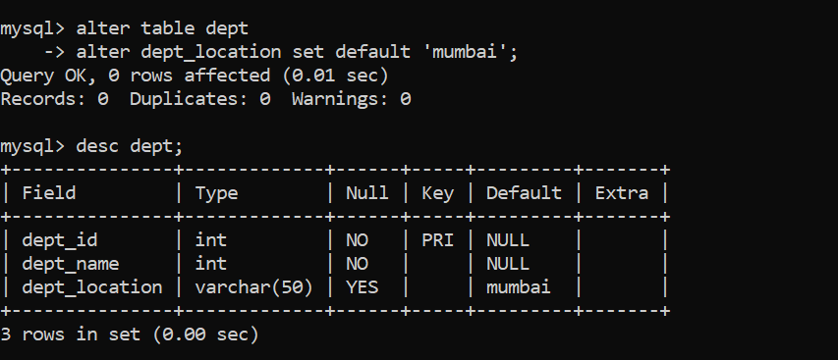

Q.2 a

2. Create table named Employee with following columns

(Emp_id int,

emp_name varchar,

job_name varchar,

salary int,

commission int,

dep_id int )

a. Add primary key to Emp_ID column

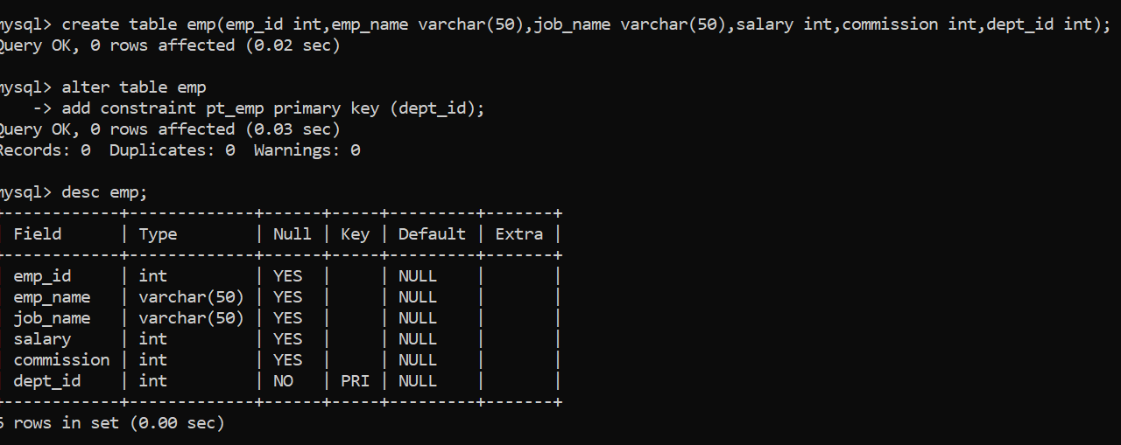

Q.2 _ b

Add foreign key to dep_id column in employee table referring

department column primary key

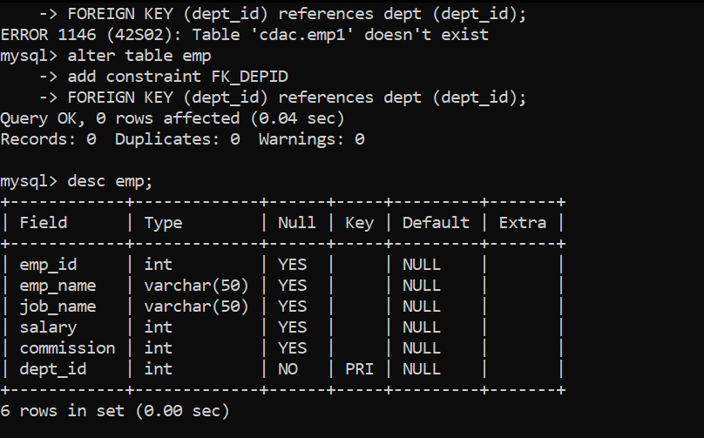

Q.2- c

Add check constraint to salary column where salary greater than or

equal to 15000

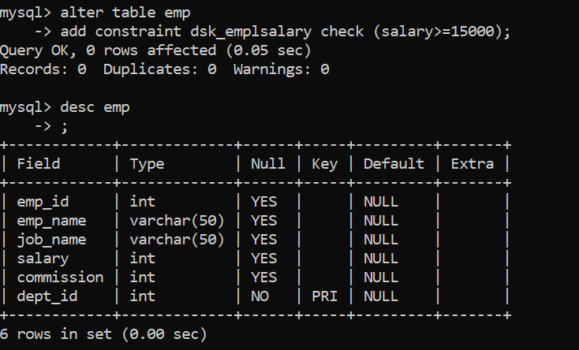

Q.2 D Add NOT NULL constraint to emp_name column

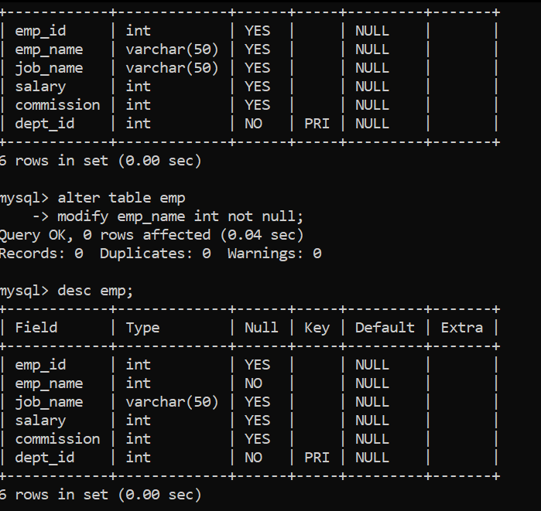

Q.3 Insert 5 Different records in Department table

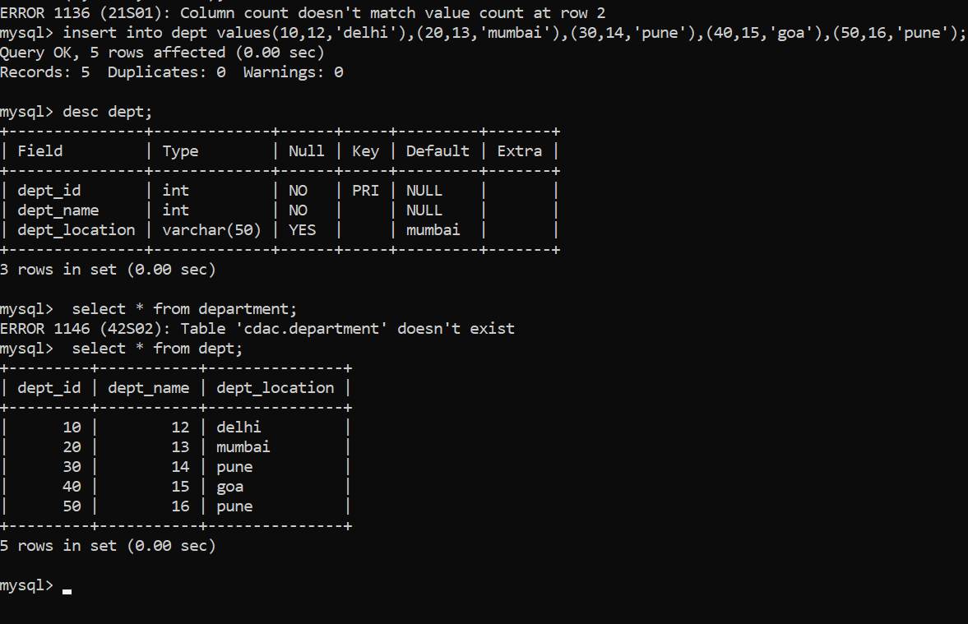

Q.4 Insert 20 Different records in Employee table where few

employees can belong to same department

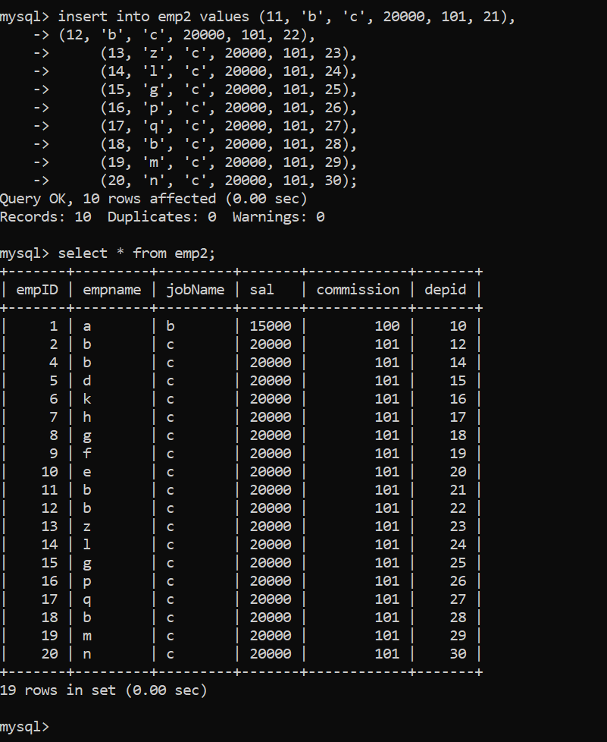

Q.5 Display all the records from department table

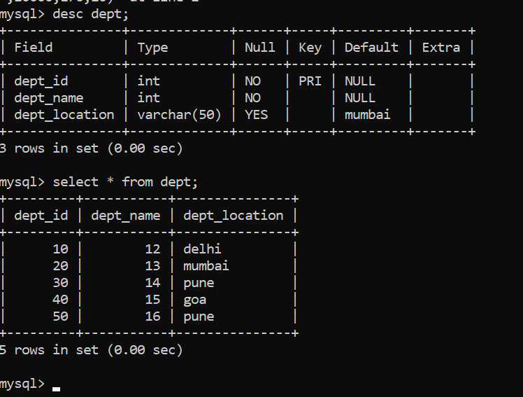

Q.6 Update Department id to a new value to any existing

department



Q.7 Display all the records from employee table



Q.8 Display Employee ID and salary of all employees

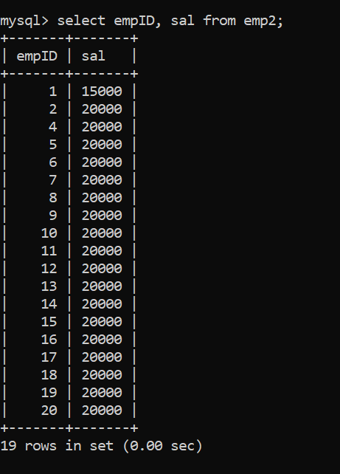

Q.9 Display count of records from employee table

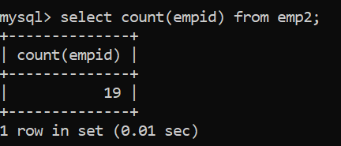

Q.10 Display count of records from employee table for a

particular department



Q.11 Add a new record in the Department Table and add new

employee in that table with new department added in

department table

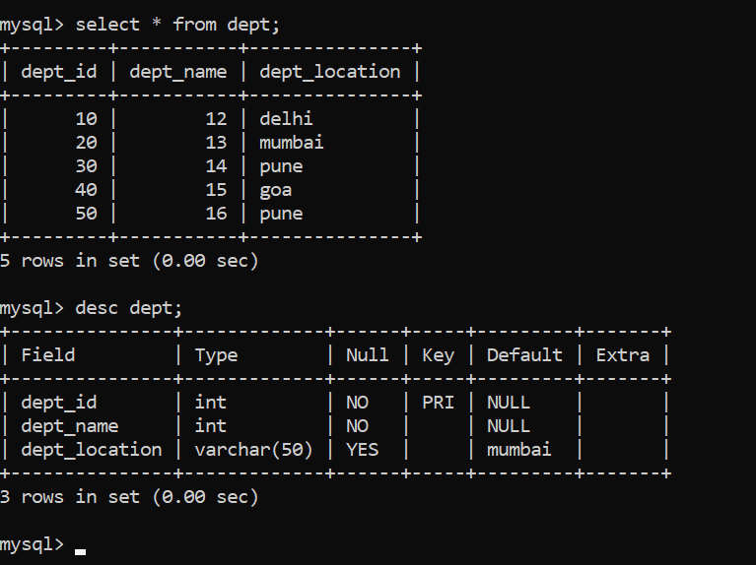

Q.12 Find the max(salary) and min(salary) from employee table

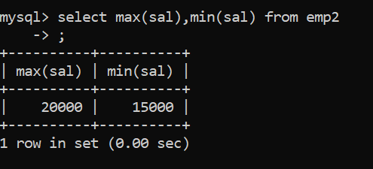

Q.13 Find the avg(salary) from employee table

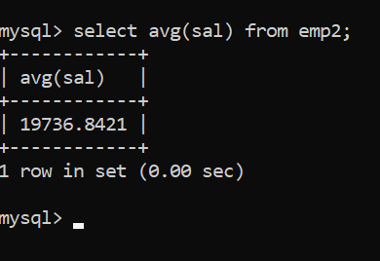

Q.14 Try to delete a record from department table where

employees are assigned to that department in the employee

table

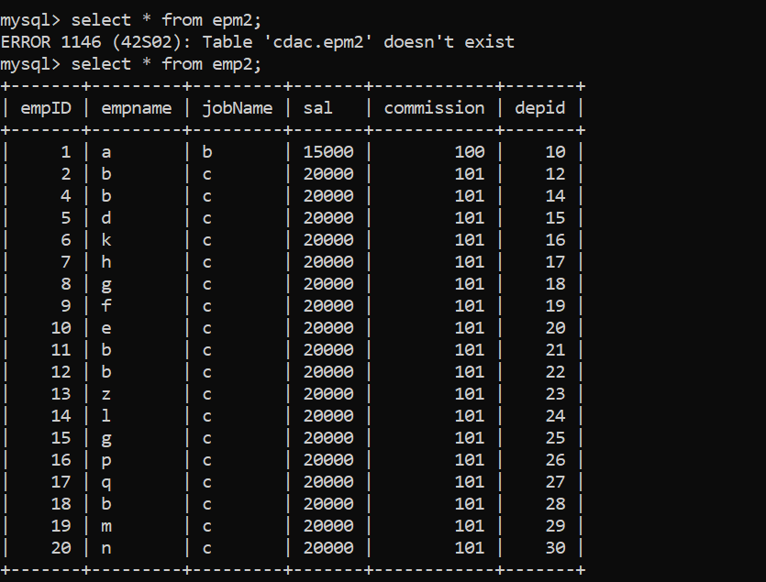

Q.15 Try to delete the employee table record 1 st then delete

that department from department table

